Functional Specification

477093 - MMM Migration and iPad
Novartis

Document Owner

Authors | Sylvain Pointeau
Department | IMS Health BTS
Published | 25th October 2010
Status | Final
Confidentiality | This document is for Novartis and IMS Health.
Copyright | © 2026 IMS Health Incorporated or its affiliates. All rights reserved.

Changes made to this document

Vers | Chapters  changed | Date | Author | Comments
0.9 |  | 02 OCT 2011 | Sylvain Pointeau | Interface description, mockups elements
0.95 |  | 13 OCT 2011 | Sylvain Pointeau | New top utility bar, mockups for KPI updated
1.0 |  | 21 NOV 2011 | Sylvain Pointeau | Trend view updated.
1.1 |  | 15 DEC 2011 | Bhaskar Ghodge | Data specification for Franchise
1.2 |  | 15 MAR 2012 | Bhaskar Ghodge | Data Specification for Brand, Corporation, Region and Country

Table of Contents
1 Introduction 3
1.1.1 Objective of document 3
2 MMM Dashboard Application 4
2.1.1 Login 4
2.1.2 Data Export Functionality 4
2.1.3 Print 4
2.1.4 Footer 5
2.2 Navigation & Homepage Layout 6
2.2.1 Homepage 6
2.2.2 Top utility bar 6
2.2.3 Primary navigation bar 6
2.2.4 “Define your Market” slider 6
2.2.5 Data row checkbox 8
2.2.6 Data table sort 9
2.2.7 Charts selection 9
2.3 Module Definitions 9
2.3.1 Market Tab 9
2.3.1.1 Market Tab - Market definition filters 10
2.3.1.2 Market Tab - Report filters 11
2.3.1.3 Market Tab – Exports 11
2.3.1.4 Market Tab - Report Output – View By 11
2.3.2 Trend View 17
2.3.2.1 Trend – Exports 18
2.3.3 KPI overview 19
2.3.3.1 KPI – Define your dashboard 20
2.3.3.2 KPI – Exports 20
2.3.3.3 KPI – Footer 21
2.3.3.4 KPI – output 22
2.4 Data Specification 26
2.4.1.1 KPI – definitions 26
2.4.1.2 View by Brand 27
2.4.1.3 View by Corporation 30
2.4.1.4 View by Country 32
2.4.1.5 View by Region 33
2.4.1.6 View by Franchise 34

Introduction
Our Understanding of the Situation

Novartis would like to re-implement the My Market Monitor (using actually flash embedded in PPT) to a full web version. The new version will source the data directly from the Enable data production so the time to availability will decrease significantly. The new version will also be compatible with IPAD (but should be viewable with a similar tablet using webkit as browser engine, however it is not covered by the present offer and it should be physically tested on all other devices than IPAD).

Objective of document
The objective of this document is to provide Novartis with a detailed overview of the functionality that the dashboard solution will deliver, the functional details are based upon the design mock up that has already been reviewed and agreed.

MMM Dashboard Application
This chapter describes all common functionality provided with a standard
dashboard like login, favorites, etc.

The Dashboard consists of four sections, each deliverying specific reports.

The application layout is divided into six main areas:
- Banner
- Primary navigation
- Market Definition filters
- Report Filters
- Report Area
- Footer

Login
Req. ID | Requirement Description & Acceptance | Comment
FSR-<No> | We will implement a Single Sign-On for the Novartis users.  Acceptance criteria: <Acceptance>  Reference: <Related User Requirement ID> | <Comment>

Data Export Functionality
Req. ID | Requirement Description & Acceptance | Comment
FSR-<No> | This option allows the user to export the current report in:  - EXCEL  - PPT  - PDF (mirroring the PPT to print)  The export to excel is only exporting the full data set (no “others”) for deeper analysis. The PPT will mirror the web page as most as possible. The PDF is generated from the PPT, convenient to print or to visualize on IPAD.  On IPAD, the export to PPT and excel are removed.  Acceptance criteria: <Acceptance>  Reference: <Related User Requirement ID> | <Comment>
Illustra-tion | 

Print
Req. ID | Requirement Description & Acceptance | Comment
FSR-<No> | Clicking the print link will ask the user to save or to display a pdf.  The PDF is an export of PPT.  On IPAD, the Pdf should be opened and not “save as…”.  Acceptance criteria: <Acceptance>  Reference: <Related User Requirement ID> | <Comment>
Illustra-tion

Footer
Req. ID | Requirement Description & Acceptance | Comment
FSR-<No> | The footer consits of 2 sections:  - On the left side, the selected report paramaters:  - Measurement: the selected measures  - Brand  - Franchise  - Region  - Country  - Time period: the selected period (MAT, YTD, MTH, QTR)  - Latest Period (loaded in the sytem for the Monthly or Quarterly data)  - Currency  - Report type (View by)  - On the right side, the data source  - IMS Monthly  - IMS Quarterly  - On the middle side, we can provide feedback, this is simply a mailto:  Acceptance criteria: <Acceptance>  Reference: <Related User Requirement ID> | <Comment>
Illustra-tion | 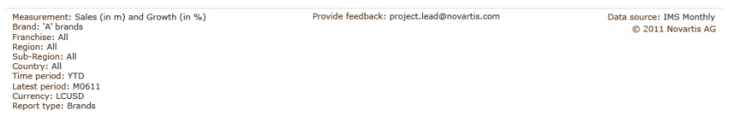

Navigation & Homepage Layout

Navigation of the dashboard is simple. Links to the 2 main report sections and the home page are available in the primary navigation bar. Additionally, the home page contains buttons providing quick access to the report sections (enabling expanded link descriptions).

Homepage

Req. ID | Requirement Description & Acceptance | Comment
FSR-<No> | Quick link buttons  Teasers to highlight dashboard content  Acceptance criteria: <Acceptance>  Reference: <Related User Requirement ID> | <Comment>
Illustra-tion

Top utility bar
Req. ID | Requirement Description & Acceptance | Comment
FSR-<No> | This a a new utility bar to handle:  - On the left, the change between monthly and quarterly data.  - On the right, welcome “firstname” “lastname” with the logout.  Acceptance criteria: <Acceptance>  Reference: <Related User Requirement ID> | <Comment>
Illustration

Primary navigation bar
Req. ID | Requirement Description & Acceptance | Comment
FSR-<No> | The user can access the main reports by a horizontal menu.  Acceptance criteria: <Acceptance>  Reference: <Related User Requirement ID> | <Comment>
Illustration | 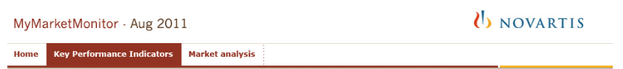

“Define your Market” slider
Req. ID | Requirement Description & Acceptance | Comment
FSR-<No> | Directly below the primary navigation bar in the report sections a slider is available. This contains all relevent report paramaters for the section. By default, this slider is open on page load. The slider remains open on report retrieval. The slider may be closed by the user by clicking the title “Define your market” or the “close panel” tab. When closed, the “Define your market” bar shall have a mouseover action (darker colour) to indicate interactivity (click to open.)  Acceptance criteria: <Acceptance>  Reference: <Related User Requirement ID> | <Comment>

Illustra-tion | Opened  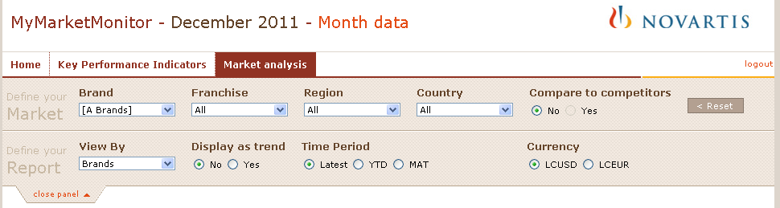  Closed  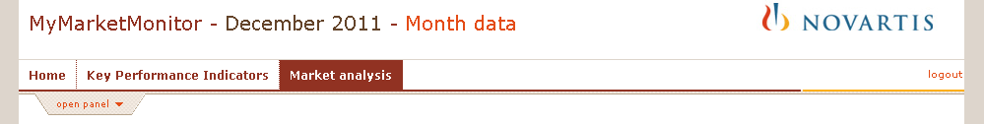

Data row checkbox
Req. ID | Requirement Description & Acceptance | Comment
FSR-<No> | For each row of returned data, a checkbox is provided to allow the user to show/hide that data within the graphs.  It has only an effect on the graph shown on screen.  It has no effect on the file export in PPT.  Excel always export the full dataset.  The box in the title is for selecting “all” or unselecting “all”.  Acceptance criteria: <Acceptance>  Reference: <Related User Requirement ID>
Illustra-tion | 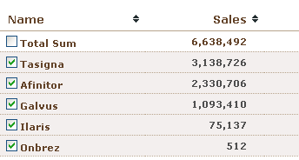

Data table sort
Req. ID | Requirement Description & Acceptance | Comment
FSR-<No> | The data table is sortable by any column.  However  - TotalSum is always first  - others (Novartis) and others (Competitors) are always at the end.  Acceptance criteria: <Acceptance>  Reference: <Related User Requirement ID>
Illustra-tion | 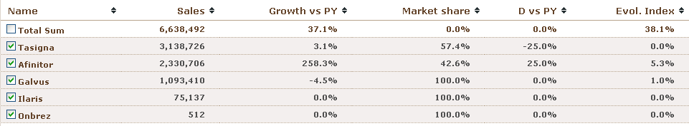

Charts selection
Req. ID | Requirement Description & Acceptance | Comment
FSR-<No> | The 2 charts are by default “Sales” and “Growth vs PY”  They can be changed to:  - Sales  - Growth vs PY  - Market share  - D vs PY  - Evol. Index  Acceptance criteria: <Acceptance>  Reference: <Related User Requirement ID>
Illustra-tion | 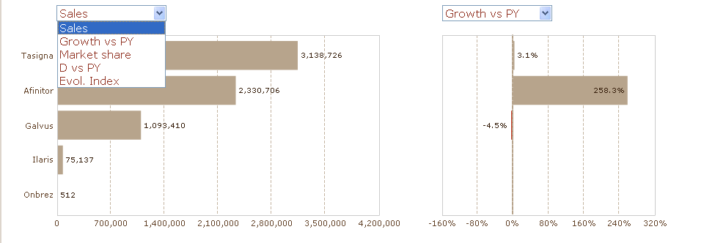

Module Definitions

Market Tab

Market Tab - Market definition filters
Req. ID | Requirement Description & Acceptance | Comment
FSR-<No> | The filters have a relationship from left to right,  Brand: (static)  All  A Brands  .. list of A brands sorted alphabetically  Separator  … list of All brands of Novartis sorted alphabetically  Franchise: (depends on Brand)  the Novartis Franchises  Region: (depends on Brand and Franchise)  All  - Region  - Sub-Region  - Sub-sub-Region  In order to simplify this hierarchy,  - Sub-sub-region should be removed if there is only one subsubregion and Sub-region = Subsubregion  - SubRegion should be removed if there is only one subregion and Region = subregion  Country: (depends on Brand, Franchise and Region)  All  … list of country…  The button reset will reset the selection in the “Define your Market” to their default value (All).  Acceptance criteria: <Acceptance>  Reference: <Related User Requirement ID> | <Comment>
Illustra-tion
Data | Default Values  All for Brand, Franchise, Region and Country  No for Compare to competitors

Market Tab - Report filters
Req. ID | Requirement Description & Acceptance | Comment
FSR-<No> | View by is defining the output:  - Brand  - franchise  - region  - country  - corporation  Display as trend is only available when Time Period is “Latest”.  Acceptance criteria: <Acceptance>  Reference: <Related User Requirement ID>
Illustra-tion
Data | Default Values  - View by = brand  - Display as trend = no  - Time period = MAT  - Currency: LCUSD

Market Tab – Exports

Req. ID | Requirement Description & Acceptance | Comment
FSR-<No> | - The Excel is exporting the complete list (groups like “others..” are expanded)  - The powerpoint have 2 slides, 1 for the 2 charts, 1 for the data table. The data table is same as the one on the screen.  - The PDF is the PPT exported as PDF.  - The PDF is known as print format, so the user should download the PDF in order to print it.  On IPAD, the export to PPT and excel are removed. The Pdf should be opened and not “save as…”.  Acceptance criteria: <Acceptance>  Reference: <Related User Requirement ID>
Illustra-tion | 
Data
KPI

Market Tab - Report Output – View By

The “View by” produces multiple outputs.

Brand
Req. ID | Requirement Description & Acceptance | Comment
FSR-<No> | - With “compare to competitors” = yes  The output will be Top9 + Others (Novartis) + Others (Competitors)  - With “compare to competitors” = no  The output will be Top9 + Others (Novartis)  Total sum is the sum of the table rows.  By default, Total Sum, Others (Novartis) and Others (Competitors) are not selected.  Acceptance criteria: <Acceptance>  Reference: <Related User Requirement ID>
Illustra-tion | 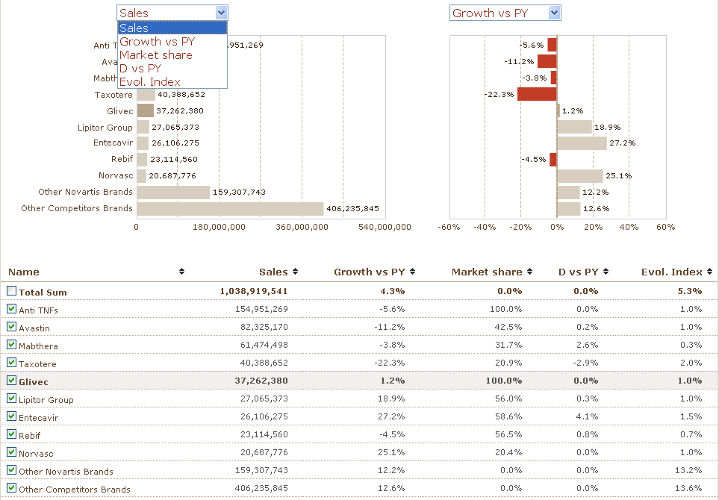
Data | Default Values  - Left chart = Sales  - Right chart = Growth vs PY  - Sorted by Sales DESC  - Total sum always at first  - Others (Novartis) and Others (Competitors) always at the end
KPI | Calculation Total Line:  Sum of the all rows in the data table.

Franchise

Req. ID | Requirement Description & Acceptance | Comment
FSR-<No> | - It will deactivate the function “compare to competitors” = yes  - With “compare to competitors” = no  The output will be Novartis Franchises  Total sum is the sum of the table rows.  By default, Total Sum is not selected.  Acceptance criteria: <Acceptance>  Reference: <Related User Requirement ID>
Illustra-tion | 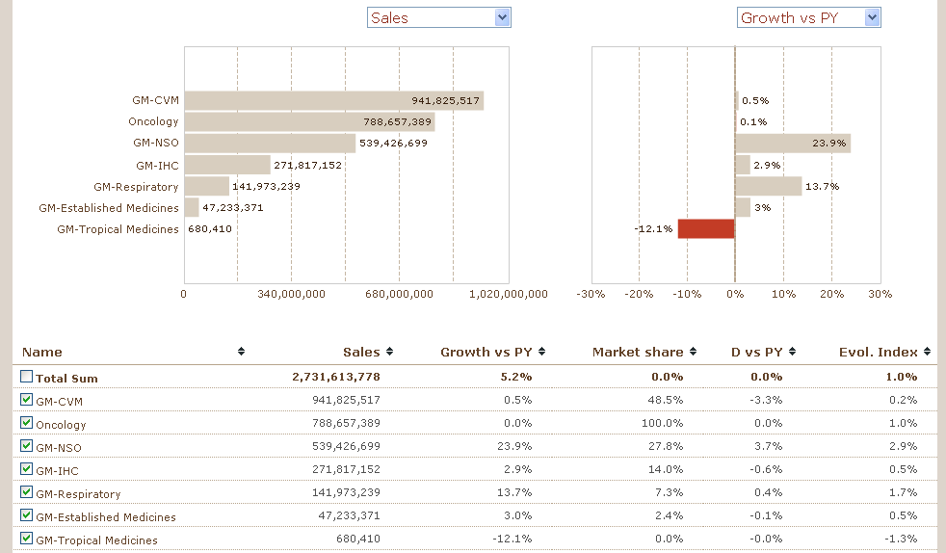
Data | Default Values  - Left chart = Sales  - Right chart = Growth vs PY  - Sorted by Sales DESC  - Total sum always at first
KPI | Calculation Total Line:  Sum of the all rows in the data table.

Country

Req. ID | Requirement Description & Acceptance | Comment
FSR-<No> | - It will deactivate the function “compare to competitors” = yes  - With “compare to competitors” = no  The output will be the total sum + Top 9 countries + others  Total sum is the sum of the table rows.  By default, Total Sum is not selected.  Acceptance criteria: <Acceptance>  Reference: <Related User Requirement ID>
Illustra-tion | 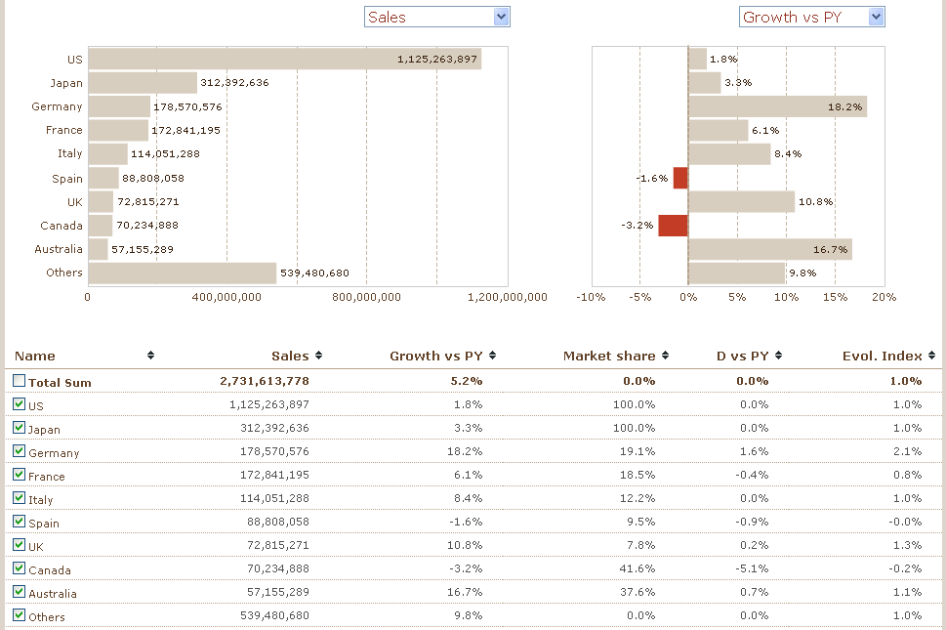
Data | Default Values  - Left chart = Sales  - Right chart = Growth vs PY  - Sorted by Sales DESC  - Total sum always at first
KPI | Calculation Total Line:  Sum of the all rows in the data table.

Corporation
Req. ID | Requirement Description & Acceptance | Comment
FSR-<No> | - It will deactivate the function “compare to competitors” = yes  - With “compare to competitors” = no  The output will be the total sum + Top 9 countries + others  Total sum is the sum of the table rows.  By default, Total Sum is not selected.  Acceptance criteria: <Acceptance>  Reference: <Related User Requirement ID>
Illustra-tion
Data | Default Values  - Left chart = Sales  - Right chart = Growth vs PY  - Sorted by Sales DESC  - Total sum always at first
KPI | Calculation Total Line:  Sum of the all rows in the data table.

Region
Req. ID | Requirement Description & Acceptance | Comment
FSR-<No> | - It will deactivate the function “compare to competitors” = yes  - With “compare to competitors” = no  The output will be the totalsum + top 9 + Others  When we select a region, it will display the subregions  When we select a subregion, it will display the subsubregion  Total sum is the sum of the table rows.  By default, Total Sum is not selected.  Acceptance criteria: <Acceptance>  Reference: <Related User Requirement ID>
Illustra-tion | 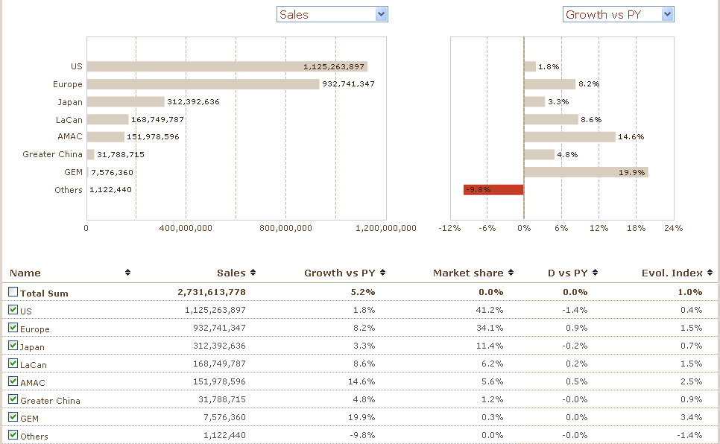
Data | Default Values  - Left chart = Sales  - Right chart = Growth vs PY  - Sorted by Sales DESC  - Total sum always at first
KPI | Calculation Total Line:  Sum of the all rows in the data table.

Trend View

This view is only available for the months (Monthly DB) or quarters (Quarterly DB).

Req. ID | Requirement Description & Acceptance | Comment
FSR-<No> | - if another time period is selected, the view will switch to “display as trend” = No  - The legend of the graph is the data table where the line color is inserted in front of the rows.  - The table is scrollable to see always the first column visible.  - View only available for “latest” (months for Monthly DB or quarters for Quarterly DB)  Acceptance criteria: <Acceptance>  Reference: <Related User Requirement ID>
Illustra-tion | 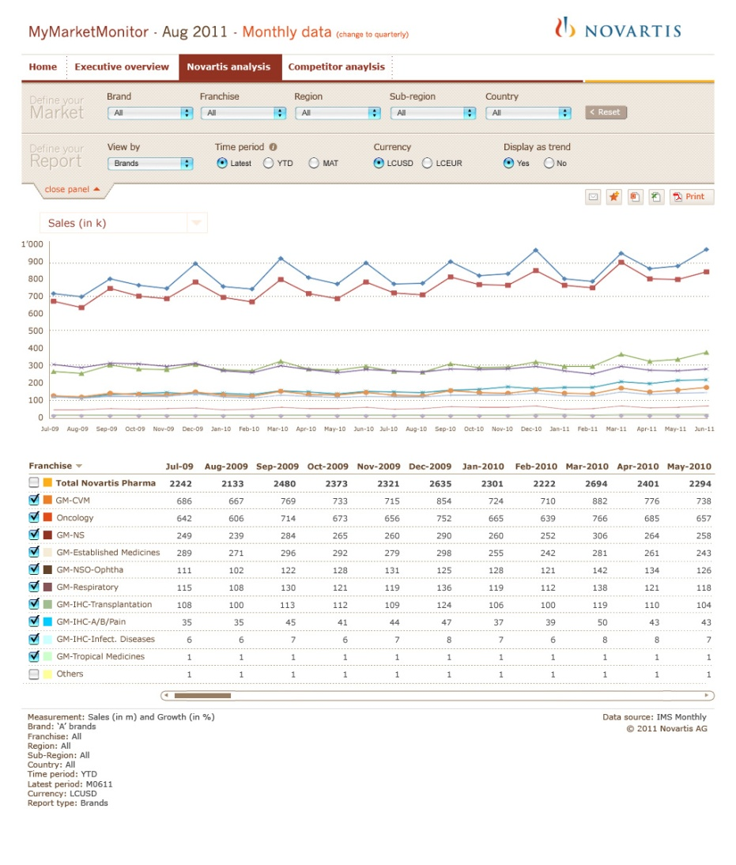
Data | Default Values  - The values selected in the market view before to enter in the trend view
KPI | Same as for the Market view

Trend – Exports

Req. ID | Requirement Description & Acceptance | Comment
FSR-<No> | - The Excel is exporting the complete list (groups like “others..” are expanded)  - The powerpoint have 2 slides, 1 for the chart, 1 for the data table. The data table is same as the one on the screen.  - The PDF is the PPT exported as PDF.  - The PDF is known as print format, so the user should download the PDF in order to print it.  On IPAD, the export to PPT and excel are removed  Acceptance criteria: <Acceptance>  Reference: <Related User Requirement ID>
Illustra-tion
Data
KPI

KPI overview
The overview will provide the overview on the main KPIs.
The trend of each item is represented with a spark line.

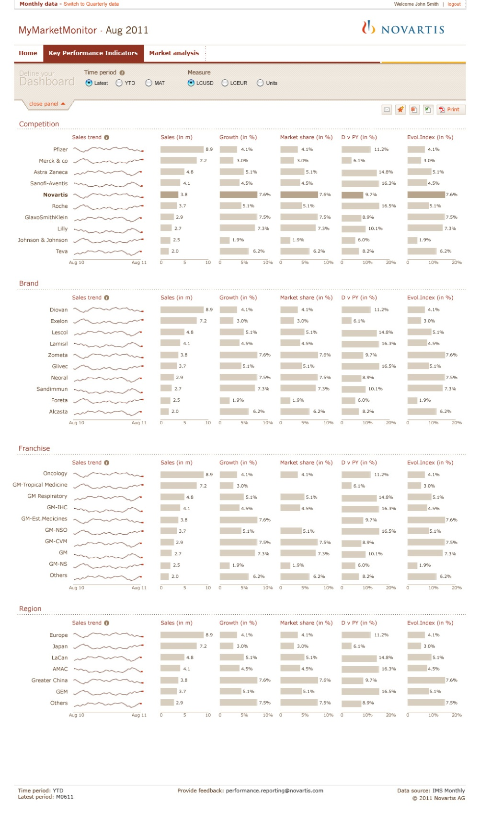

KPI – Define your dashboard
Req. ID | Requirement Description & Acceptance | Comment
FSR-<No> | Latest will be the latest month or the latest quarter according to the selected database (MTH or QTR)  LCEUR is calculated from LCUSD. The factor is given by Novartis or MIDAS [TBD].  Acceptance criteria: <Acceptance>  Reference: <Related User Requirement ID>
Illustra-tion | 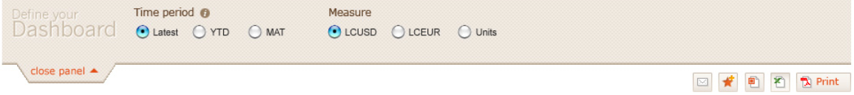
Data | Default Values  - Time Period = latest  - Measure = LCUSD
KPI

KPI – Exports

Req. ID | Requirement Description & Acceptance | Comment
FSR-<No> | - The PPT and Excel should not export the sparklines.  - The PPT exports should export each section in a separate slide  - The Excel should export the data behind the graphs, each section should be in a separate sheet. It should not contain “others” but the full list (for competitors for instance)  - The PDF is known as print format, so the user should download the PDF in order to print it.  On IPAD, the export to PPT and excel are removed  Acceptance criteria: <Acceptance>  Reference: <Related User Requirement ID>
Illustra-tion
Data
KPI

KPI – Footer

Req. ID | Requirement Description & Acceptance | Comment
FSR-<No> | Should be indicated to the bottom left:  - Time Period  - Measure  - Latest period = latest period for the monthly or quarterly database depending on the selected database.  On the bottom right:  - The datasource: should be  IMS Monthly when the monthly database is selected  IMS Quarterly when the quarterly database is selected  Provide feedback is just a mailto: with the subject “My Market Monitor : feedback”  Acceptance criteria: <Acceptance>  Reference: <Related User Requirement ID>
Illustra-tion | 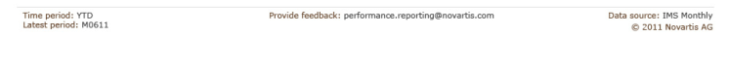
Data
KPI

KPI – output
There are four sections

KPI – Competition
Req. ID | Requirement Description & Acceptance | Comment
FSR-<No> | This is equivalent to the report Market – view by corporation  Here we display:  - the Top 9 + Novartis if Novartis is not in the top10  - The Top10 if Novartis in in the top 10  Novartis values should be highlighted (standard color as specified earlier)  Each item should have :  - the sales trend, a spark line with monthly data for the Monthly database or quarterly data for the Quarterly database, so it is independent of the selected time period  - Sales  - Market share  - Growth vs PY  - D vs PY  - Evol Index  Acceptance criteria: <Acceptance>  Reference: <Related User Requirement ID>
Illustra-tion | 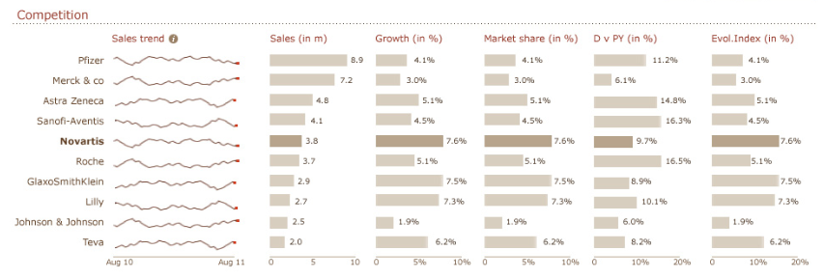
Data
KPI | Calculation should follow the same rules as for the Market – view by corporation

KPI – A Brands

Req. ID | Requirement Description & Acceptance | Comment
FSR-<No> | This is equivalent to the report Market – view by Brands with A brands as selected  It displays the full list of A brands  Each item should have :  - the sales trend, a spark line with monthly data for the Monthly database or quarterly data for the Quarterly database, so it is independent of the selected time period  - Sales  - Market share  - Growth vs PY  - D vs PY  - Evol Index  Acceptance criteria: <Acceptance>  Reference: <Related User Requirement ID>
Illustra-tion | 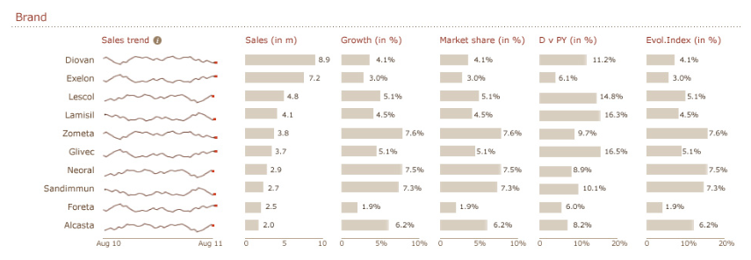
Data
KPI | Calculation should follow the same rules as for the Market – view by Brands – with A brands selected

KPI – Novartis Franchise
Req. ID | Requirement Description & Acceptance | Comment
FSR-<No> | This is equivalent to the report Market – view by Franchise  Each item should have :  - the sales trend, a spark line with monthly data for the Monthly database or quarterly data for the Quarterly database, so it is independent of the selected time period  - Sales  - Market share  - Growth vs PY  - D vs PY  - Evol Index  Acceptance criteria: <Acceptance>  Reference: <Related User Requirement ID>
Illustra-tion | 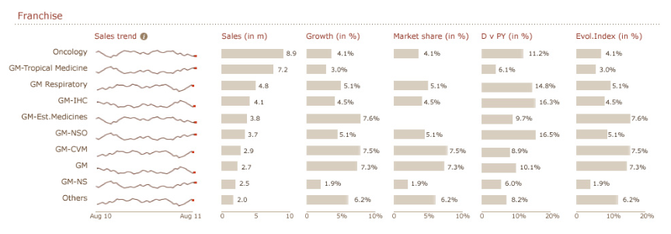
Data
KPI | Calculation should follow the same rules as for the Market – view by Franchise

KPI – Region
Req. ID | Requirement Description & Acceptance | Comment
FSR-<No> | This is equivalent to the report Market – view by Region  The regions are the top regions:  Each item should have :  - the sales trend, a spark line with monthly data for the Monthly database or quarterly data for the Quarterly database, so it is independent of the selected time period  - Sales  - Market share  - Growth vs PY  - D vs PY  - Evol Index  Acceptance criteria: <Acceptance>  Reference: <Related User Requirement ID>
  Europe
  Japan
  LaCan
  AMAC
  Greater China
  GEM
  Others
Illustra-tion | 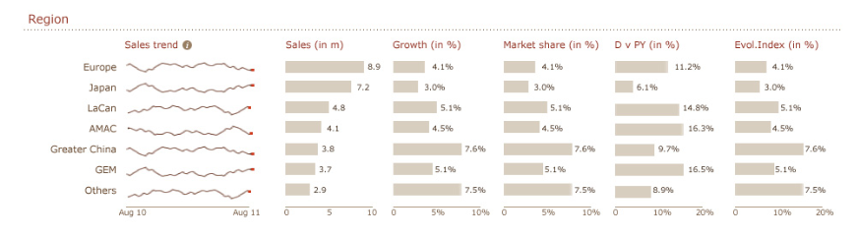
Data
KPI | Calculation should follow the same rules as for the Market – view by region (all as selected region)

Data Specification

KPI – definitions

Req. ID | Requirement Description & Acceptance
FSR-D01 | The following KPIs will be available in MMM v3.0 for Latest (MTH/QTR), YTD and MAT reporting periods for Monthly and Quarterly data.  - Sales (in Mio)  - Growth v/s P.Y.  - Market share (in %)  - Mkt. Shr. D. v/s PY (in %)  - Evolution index (number)  The total market consists of Therapuetic area General Medicine and Oncology. The sales corresponding to any other therapuetic areas should not be considered in KPI calculations.  For every output the Total line is also shown. The total line is sum of all the records in the output. Only growth KPI is calculated for Total line. It is not possible to show the market share, D vs PY and Evol. Index because of the different selections that are possible in MMM.  Acceptance criteria: The KPIs should be aligned with data in PADDS.  Reference: <Related User Requirement ID>
Illustra-tion
  KPI | Definition | view by Brand | Franchise | Region | Country
  Sales value  Sell Out (value);  Average Sales per selling pharma; | Sales in value terms - LC_EURO, LC_USD | Sales for a brand depending on selection (All, Brand, Franchise, Region, SubRegion, Country) | Sales for a Franchise depending on selection (All, Brand, Franchise, Region, SubRegion, Country) | Sales for a Region depending on selection (All, Brand, Franchise, Region, SubRegion, Country) | Sales for a Country depending on selection (All, Brand, Franchise, Region, SubRegion, Country)
  Growth vs PY | Growth versus previous period (same period previous year) | =(Sales Curr Year - Sales Prev Year)/Sales Prev Year | =(Sales Curr Year - Sales Prev Year)/Sales Prev Year | =(Sales Curr Year - Sales Prev Year)/Sales Prev Year | =(Sales Curr Year - Sales Prev Year)/Sales Prev Year
  Market share% | Market share of view by selection: Shown as a percentage of sales. | =Sales for Novartis Brand/Market Segment Sales (prio 1)*100 | =Sales for BF/Indication Area Sales*100 | =Sales for Region filter on Nov. Ph/Total Sales for Region*100 | =Sales for Country filter on Nov. Ph/Total Sales for Region*100
  Mkt. Shr. Delta vs PY | Difference bewteen Mkt. Share between cuurent and previous year. | =Curr Year Mkt. Shr - Prev Year Mkt. Shr | 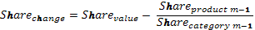  =Curr Year Mkt. Shr - Prev Year Mkt. Shr | =Curr Year Mkt. Shr - Prev Year Mkt. Shr | =Curr Year Mkt. Shr - Prev Year Mkt. Shr
  Evol. Index | Evolution of NVS brand, business franchise, region, country w.r.t. to growth of the market. | =(1+Product growth%)/(1+Market Growth%)*100 | =(1+Product growth%)/(1+Market Growth%)*100 | =(1+Product growth%)/(1+Market Growth%)*100 | =(1+Product growth%)/(1+Market Growth%)*100
Data | NA
KPI | NA

View by Brand

Req. ID | Requirement Description & Acceptance | Comment
FSR-D02 | The graph/trend view and table will display the data for Brand/Brand group based on different selections in ‘Define your Market’.  For Compared to Competitor = NO  - If a Brand is selected in Brand drop down list, then the KPIS will be displayed corresponding to the selected brand.  - If a Brand Group is selected in Brand drop down list, then the KPIS will be displayed corresponding to the brands under the selected Brand group.  For Compared to Competitor = YES  - If a Brand is selected in Brand drop down list, then the KPIS will be displayed corresponding to the brand along with its competitors brands.  - If a Brand Group is selected in Brand drop down list, then the KPIS will be displayed corresponding to the brand group along with its competitors brand groups.  Drill down is possible at region and country level.  If for a given selection of brand, frachise, region and country, if the brand does not exists, then No Data will be displayed.  Acceptance criteria: Brand and Brand Group Sales, Market Share, Growth etc. is aligned with PADDS.  Reference: <Related User Requirement ID>
Illustra-tion | Brand Group Selected (Compared to Competuitor = NO)  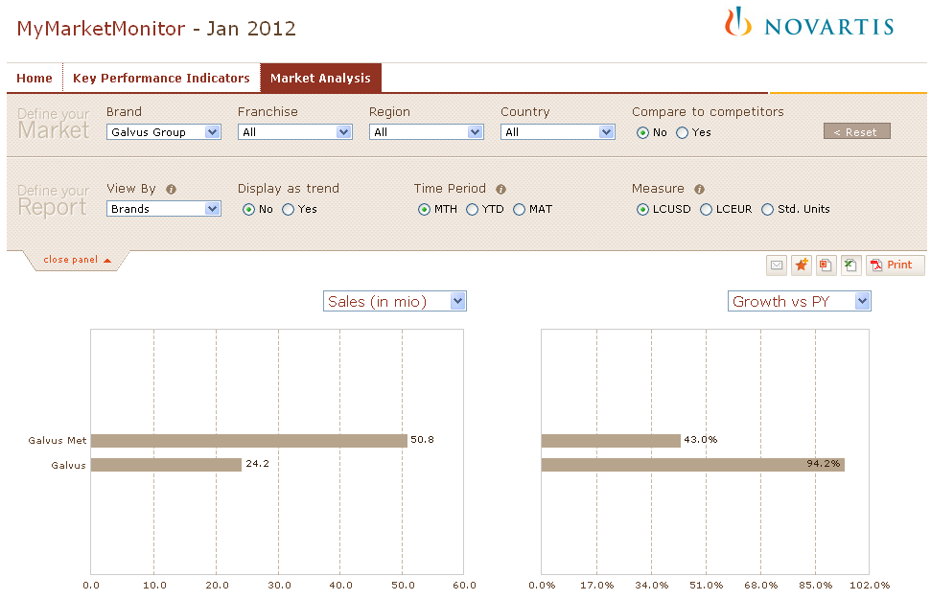  Brand Selected (Compared to Competitor = NO)  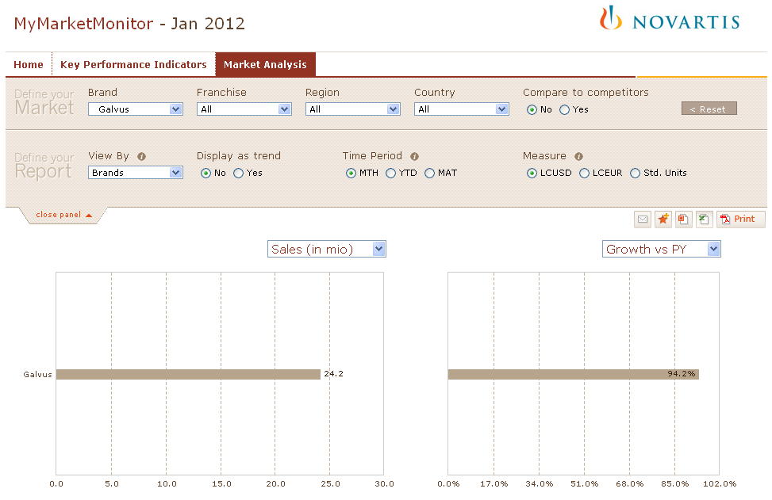  Brand Group Selected (Compared to Competitor = YES)  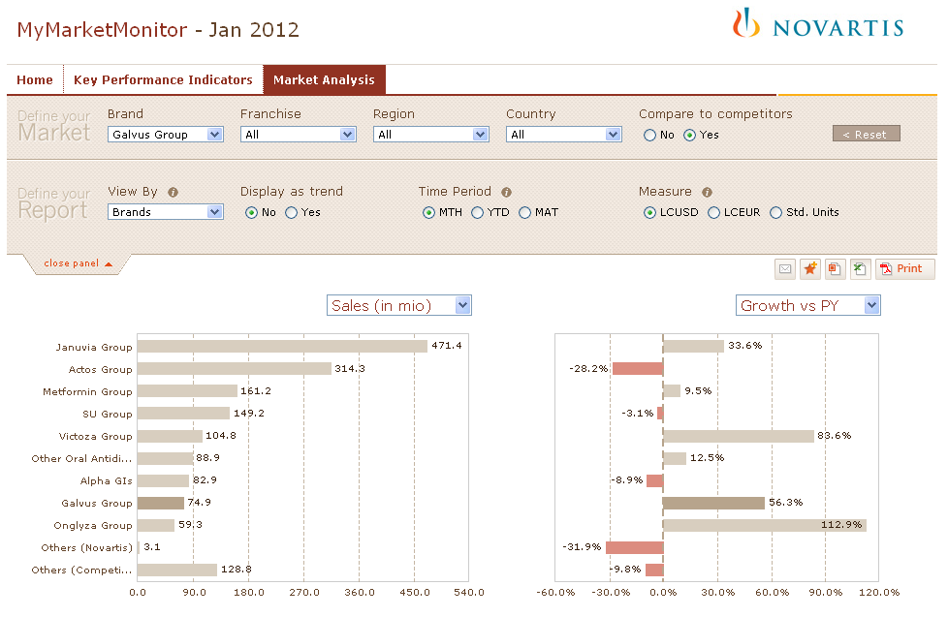  Brand Selected (Compared to Competitor = YES)  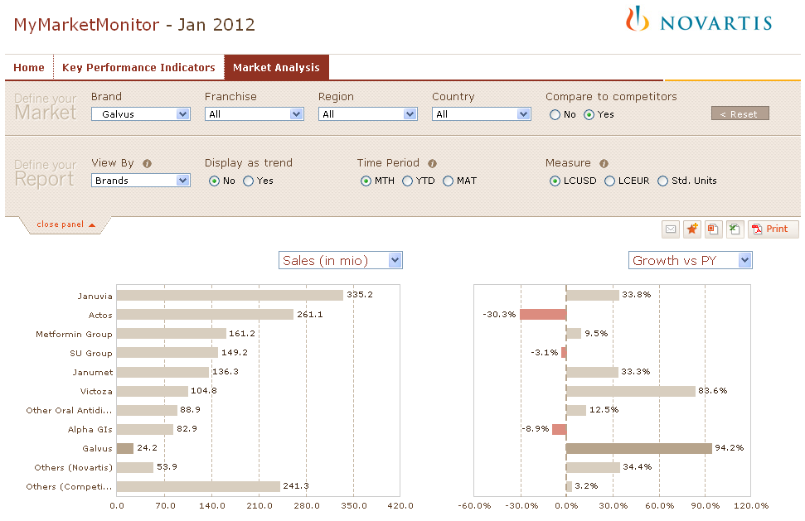
Data | e.g. Brand = Galvus Group, Compared to Competior = YES  e.g. Brand = Galvus, Compared to Competior = YES
  Brand Group | Sales (in mio) | Growth vs PY | Market Share | D Vs PY | Evol. Index
  Januvia Group | 471.4 | 33.6% | 28.8% | 5.9% | 126
  Actos Group | 314.3 | -28.2% | 19.2% | -9.2% | 68
  Metformin Group | 161.3 | 9.4% | 9.8% | 0.3% | 103
  SU Group | 149.2 | -3.1% | 9.1% | -0.9% | 91
  Victoza Group | 104.8 | 83.6% | 6.4% | 2.7% | 173
  Other Oral Antidiabetics | 89.0 | 12.4% | 5.4% | 0.3% | 106
  Alpha GIs | 82.9 | -8.9% | 5.1% | -0.8% | 86
  Galvus Group | 75.0 | 56.3% | 4.6% | 1.5% | 147
  Onglyza Group | 59.3 | 112.9% | 3.6% | 1.8% | 200
  Byetta | 52.7 | -1.3% | 3.2% | -0.2% | 93
  SU+Metformin | 39.7 | -4.7% | 2.4% | -0.3% | 90
  Nesina Group | 15.4 | 921.9% | 0.9% | 0.8% | 962
  Starlix | 12.1 | -25.5% | 0.7% | -0.3% | 70
  Symlin | 7.8 | -3.1% | 0.5% | 0.0% | 91
  Avandia Group | 4.1 | -84.5% | 0.2% | -1.5% | 15
  Brand | Sales (in mio) | Growth vs PY | Market Share | D Vs PY | Evol. Index
  Januvia | 335.2 | 33.8% | 20.5% | 4.2% | 126
  Actos | 261.1 | -30.3% | 15.9% | -8.4% | 66
  Metformin Group | 161.3 | 9.4% | 9.8% | 0.3% | 103
  SU Group | 149.2 | -3.1% | 9.1% | -0.9% | 91
  Janumet | 136.3 | 33.3% | 8.3% | 1.7% | 125
  Victoza | 104.8 | 83.6% | 6.4% | 2.7% | 173
  Other Oral Antidiabetics | 89.0 | 12.4% | 5.4% | 0.3% | 106
  Alpha GIs | 82.9 | -8.9% | 5.1% | -0.8% | 86
  Byetta | 52.7 | -1.3% | 3.2% | -0.2% | 93
  Galvus Met | 50.8 | 43.0% | 3.1% | 0.8% | 135
  Onglyza | 48.2 | 77.6% | 2.9% | 1.2% | 167
  ActoPlus Met | 44.0 | -20.0% | 2.7% | -0.9% | 75
  SU+Metformin | 39.7 | -4.7% | 2.4% | -0.3% | 90
  Galvus | 24.2 | 94.2% | 1.5% | 0.7% | 183
  Nesina | 15.4 | 921.9% | 0.9% | 0.8% | 962
  Starlix | 12.1 | -25.5% | 0.7% | -0.3% | 70
  Kombiglyze XR | 11.0 | 1508.0% | 0.7% | 0.6% | 1'513
  Symlin | 7.8 | -3.1% | 0.5% | 0.0% | 91
  Actos FDC Other | 6.1 | 33.3% | 0.4% | 0.1% | 125
  Duetact | 3.1 | -11.1% | 0.2% | 0.0% | 84
  Avandia | 2.7 | -82.5% | 0.2% | -0.8% | 16
  Avandamet | 0.8 | -90.4% | 0.1% | -0.5% | 9
  Avandia FDC Other | 0.4 | 4.0% | 0.0% | 0.0% | 98
  Avandaryl | 0.1 | -92.8% | 0.0% | -0.1% | 7
KPI | Attached excel sheet shows calculation of KPIs for above example. Please refer to FS-D01 is for all the calclaution.  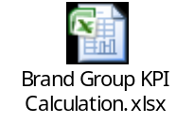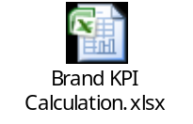

View by Corporation

Req. ID | Requirement Description & Acceptance | Comment
FSR-D03 | The graph/trend view and table will display the data for Corporation based on different selections in ‘Define your Market’.  Only the Multi National Corporations (As defined in source system – NVS Market DHW), are displayed. Rest all the corporations are grouped under Others.  For Compared to Competitor = NO  - The sales corresponding to Novartis Pharma Plus is considered. The following filtter need to be used in addition to therapuetic area fileter  - NvsCorporation = Novartis Pharma Plus OR  - NvChannel in Novartis Pharma, Parallel Import and Novartis Co-marketing  For Compared to Competitor = YES  - For Competitor Corporation, Corporation filter will be used.  - For Novartis Corporation, sales corresponding to Novartis Pharma Plus is considered. The following filtter need to be used in addition to therapuetic area fileter  - NvsCorporation = Novartis Pharma Plus OR  - NvChannel in Novartis Pharma, Parallel Import and Novartis Co-marketing  Drill down is possible at franchise, brand, region and country level.  If for a given selection of brand, frachise, region and country, if the brand does not exists, then No Data will be displayed.  Acceptance criteria: The Corporation Sales, Market Share, Growth etc is aligned with PADDS for same data.  Reference: <Related User Requirement ID>
Illustra-tion | View by Corporation (Compared to Competitor = NO)  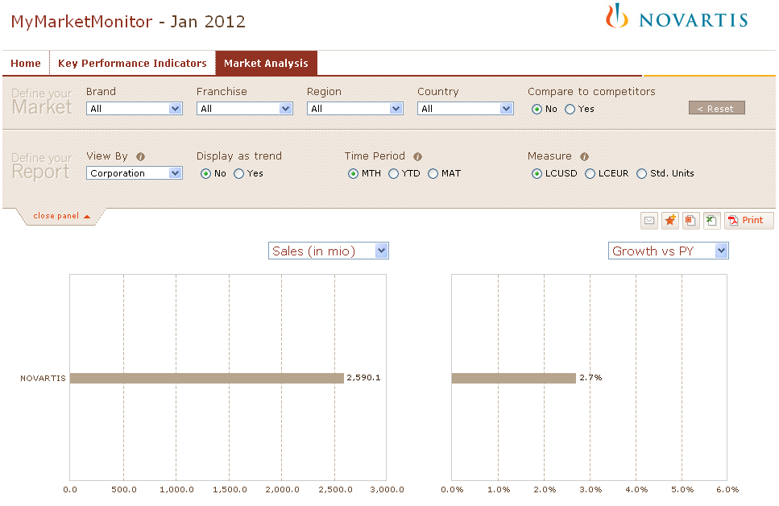  View by Corporation (Compared to Competitor = YES)  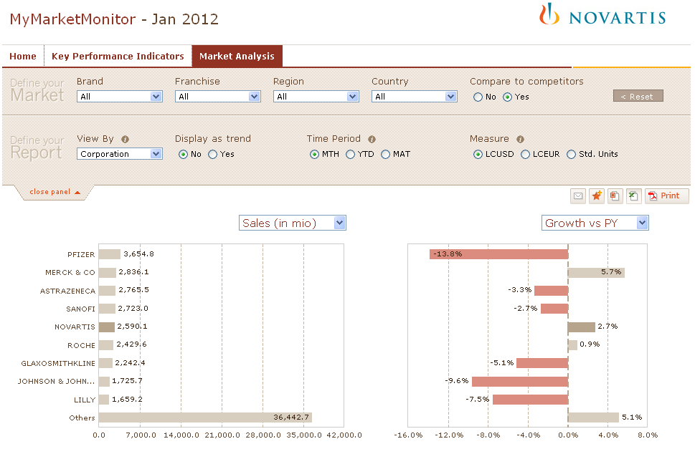
Data | e.g. Compared to Competitor = YES
  Brand | Sales (in mio) | Growth vs PY | Market Share | D Vs PY | Evol. Index
  PFIZER | 3'654'836 | -13.8% | 6.2% | -1.1% | 85
  MERCK & CO | 2'836'102 | 5.7% | 4.8% | 0.2% | 104
  ASTRAZENECA | 2'765'501 | -3.3% | 4.7% | -0.2% | 95
  SANOFI | 2'723'014 | -2.7% | 4.6% | -0.2% | 96
  NOVARTIS | 2'590'102 | 2.7% | 4.4% | 0.1% | 101
  ROCHE | 2'470'632 | 1.1% | 4.2% | 0.0% | 100
  GLAXOSMITHKLINE | 2'242'391 | -5.1% | 3.8% | -0.3% | 94
  JOHNSON & JOHNSON | 1'725'669 | -9.6% | 2.9% | -0.4% | 89
  LILLY | 1'659'156 | -7.5% | 2.8% | -0.3% | 91
KPI | Attached excel sheet shows calculation of KPIs for above example. Please refer to FS-D01 is for all the calclaution.  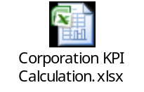

View by Country

Req. ID | Requirement Description & Acceptance | Comment
FSR-D04 | The graph/trend view and table will display the data for Country based on different selections in ‘Define your Market’.  Drill down is possible at brand and Fracnhise level. If country and region selection is not aligned, then no data would be displayed.  Compared to competitor is disabled when viewing by by Country.  Acceptance criteria: Country Sales, Market Share, Growth etc is aligned with PADDS for same data.  Reference: <Related User Requirement ID>
Illustra-tion | 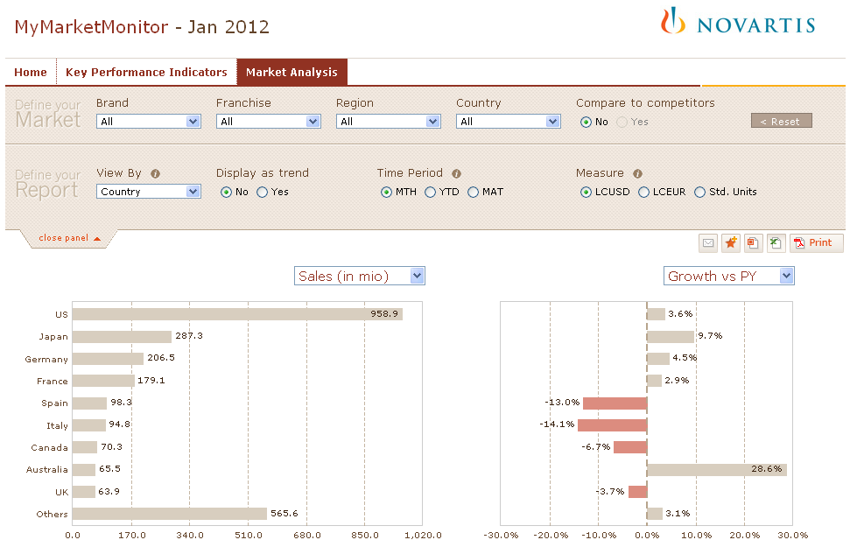
Data
  Country | Sales (in mio) | Growth vs PY | Market Share | D Vs PY | Evol. Index
  US | 958.9 | 3.6% | 4.1% | 0.2% | 104
  Japan | 287.3 | 9.7% | 4.5% | 0.2% | 105
  Germany | 206.5 | 4.5% | 6.6% | 0.0% | 100
  France | 179.1 | 2.9% | 5.5% | 0.0% | 100
  Spain | 98.3 | -13.0% | 5.6% | -0.5% | 92
  Italy | 94.8 | -14.1% | 4.3% | -0.7% | 86
  Canada | 70.3 | -6.7% | 4.1% | -0.4% | 91
  Australia | 65.5 | 28.6% | 7.5% | 1.3% | 122
  UK | 63.9 | -3.7% | 4.0% | -0.3% | 93
KPI | Attached excel sheet shows calculation of KPIs for above example. Please refer to FS-D01 is for all the calclaution.  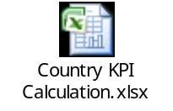

View by Region

Req. ID | Requirement Description & Acceptance | Comment
FSR-D05 | The graph/trend view and table will display the data for Region based on different selections in ‘Define your Market’.  Drill down is possible at brand and Fracnhise level. If country and region selection is not aligned, then no data would be displayed.  Compared to competitor is disabled when viewing by Region.  Acceptance criteria: The Region Sales, Market Share, Growth etc is aligned with PADDS for same data.  Reference: <Related User Requirement ID>
Illustra-tion | 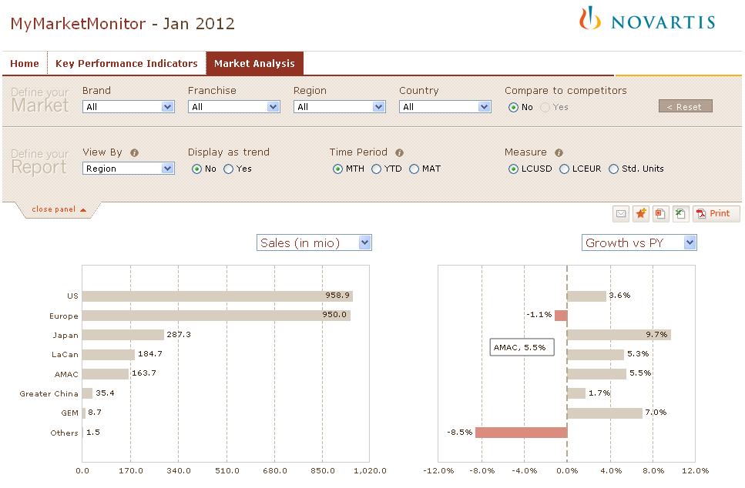
Data
  Country | Sales (in mio) | Growth vs PY | Market Share | D Vs PY | Evol. Index
  Total | 2'590.1 | 2.7%
  US | 958.9 | 3.6% | 4.1% | 0.2% | 104
  Europe | 950.0 | -1.1% | 5.3% | -0.1% | 98
  Japan | 287.3 | 9.7% | 4.5% | 0.2% | 105
  LaCan | 184.7 | 5.3% | 4.0% | -0.2% | 95
  AMAC | 163.7 | 5.5% | 4.6% | 0.1% | 103
  Greater China | 35.4 | 1.7% | 1.1% | 0.0% | 103
  GEM | 8.7 | 7.0% | 4.5% | 0.5% | 113
  Others | 1.5 | -8.5% | 2.8% | -0.5% | 85
KPI | Attached excel sheet shows calculation of KPIs for above example. Please refer to FS-D01 is for all the calclaution.  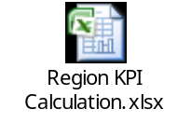

View by Franchise

Req. ID | Requirement Description & Acceptance | Comment
FSR-D06 | The graph and table will display the numbers corresponding to the business franchise group based on selection in ‘Define your Market’.  If a brand and its corresponding business franchise is selected, the sales of the business franchise will be the same as the sales of the brand. Further, drill down is possible at region and country level.  Compared to competitor is disabled when viewing by by Franchise.  If a brand and franchise selection is not aligned then No Data will be displayed.  Acceptance criteria: The business franchise Sales, Market Share, Growth etc is ailgned with PADDS for same data.  Reference: <Related User Requirement ID>
Illustra-tion | 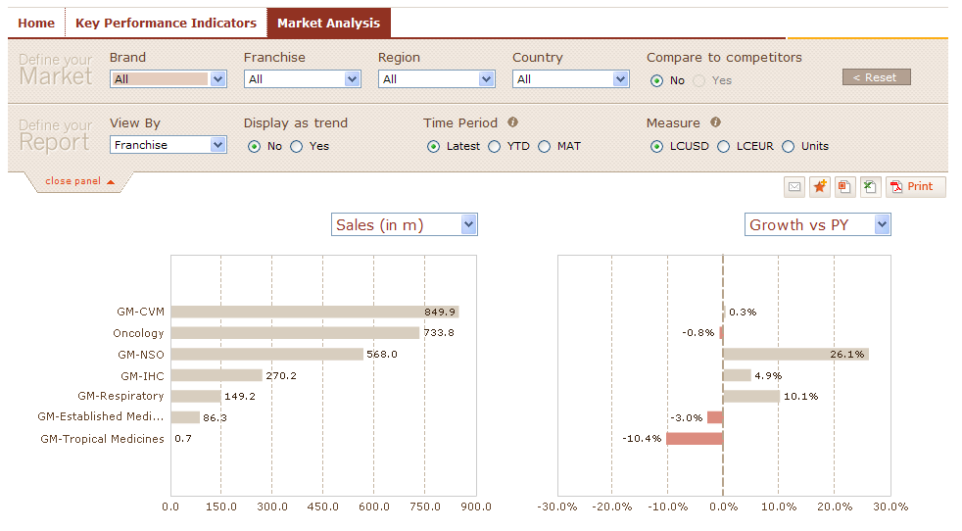  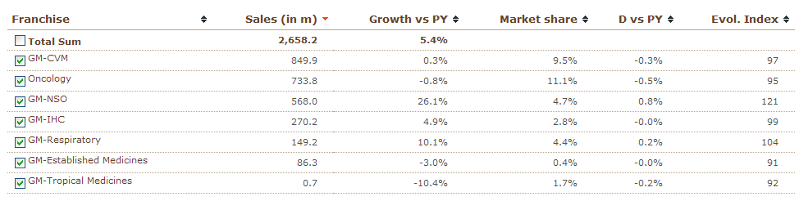
Data | Please find below the table showing the data for Latest Period
  Franchise | Sales (in Mio) | Growth V/s PY | Mkt Shr. | D. vs PY | Evol Index
  GM-CVM | 797.0 | 1.4 | 8.9 | -0.2 | 98
  GM-Established Medicines | 300.4 | -2.8 |  |  | 91
  GM-IHC | 137.6 | 7.7 | 1.4 | 0.0 | 102
  GM-NSO | 544.5 | 27.4 | 4.5 | 0.8 | 123
  GM-Respiratory | 144.0 | 10.9 | 4.3 | 0.2 | 105
  GM-Tropical Medicines | 0.7 | -10.4 | 1.7 | -0.2 | 92
  Oncology | 733.8 | -0.8 | 11.1 | -0.5 | 95
KPI | Attached excel sheet shows calculation of KPIs for above example. Please refer to FS-D01 is for all the calclaution.  